OPERATING SYSTEMS – PART 2
SCHEDULING ALGORITHMS 2

(Round Robin Scheduling Process)
1. Consider the following set of processes, assumed to have arrived at time 0. Consider the CPU scheduling algorithms Shortest Job First (SJF) and Round Robin (RR). For RR, assume that the processes are scheduled in the order: P1, P2, P3, P4.

Process | Burst Time (in ms)
P1 | 8
P2 | 7
P3 | 2
P4 | 4

If the time quantum for RR is 4 ms, then the absolute value of the difference between the average turnaround times (in ms) of SJF and RR (round off to 2 decimal places is_______
a) 4.25 b) 5.25 c) 5.50 d) 6.25

(Choose the correct option)
2. Which of the following statements are TRUE for Multilevel Queue Scheduling?

1. The main disadvantage of Multilevel Queue Scheduling is the problem of starvation for lower-level processes.

2. With the help of this scheduling we can apply various kind of scheduling for different kind of processes.

3. There are three types of processes and each set of processes can have a different scheduling algorithm. Example of scheduling: For System Processes: First Come First Serve(FCFS) Scheduling, For Interactive Processes: Shortest Job First (SJF) Scheduling, For Batch Processes: Round Robin(RR) Scheduling

a) 1 and 2 are correct b) 2 and 3 are correct
c) 1 and 3 are correct d) All the statements are correct

(Choose the correct option)
3. Which of the following statements are TRUE for Multilevel Queue Scheduling and Multilevel Feedback Queue Scheduling?

1. In the Multilevel queue (MLQ) processes are classified into different groups, whereas the Multilevel Feedback queue (MLFQ) contains two queues, lower-priority queues and higher priority queues.

2. In the Multilevel queue (MLQ), there is no possibility of starvation.

3. In the Multilevel queue (MLQ) the processes are permanently assigned to one queue, whereas the Multilevel Feedback queue (MLFQ) it allows a process to move between the queues.

Note: A similar question was asked in Adobe
a) 1 and 2 are correct b) 2 and 3 are correct
c) 1 and 3 are correct d) All the statements are correct

(Simplest Algorithm)
4. Which among the following is the simplest CPU scheduling algorithm by far?
a) Shortest Job First Scheduling b) Priority Scheduling
c) Round Robin Scheduling d) First-Come, First-Served Scheduling

ASSIGNMENT

(Round Robin Scheduling)
5. Consider the following set of processes with their arrival times and burst time (in milliseconds) as given below. If the Operating System uses Round Robin Scheduling algorithm with time quantum=2 units, then what is the average turnaround time and average waiting time of the processes?

Process ID | Arrival Time | Burst Time
P1 | 0 | 5
P2 | 1 | 3
P3 | 2 | 1
P4 | 3 | 2

a) Turnaround time: 7.25 milliseconds, Waiting time: 4.50 milliseconds
b) Turnaround time: 8.30 milliseconds, Waiting time: 5.40 milliseconds
c) Turnaround time: 6.37 milliseconds, Waiting time: 4.02 milliseconds
d) Turnaround time: 7.02 milliseconds, Waiting time: 3.17 milliseconds

()
6. Consider the following set of processes, with arrival times and the required CPU-burst times given in milliseconds.

Process | Arrival Time | Burst Time
P1 | 0 | 4
P2 | 2 | 2
P3 | 3 | 3

What is the sequence in which the processes are completed? Assume round robin scheduling with a time quantum of 2 milliseconds
a) P1, P2, P3 b) P2, P1, P3 c) P3, P2, P1 d) P2, P3, P1

(Choose the correct option)
7. For the processes listed in the following table, which of the following scheduling schemes will give the lowest average turnaround time?

Process | Arrival Time | Burst Time (in ms)
P1 | 0 | 3
P2 | 1 | 6
P3 | 4 | 4
 | 6 | 2

a) First Come First Serve b) Non-preemptive Shortest Job First
c) Shortest Remaining Time d) Round Robin with Quantum value two

(Choose the correct option)
8. Consider an arbitrary set of CPU-bound processes with unequal CPU burst lengths submitted at the same time to a computer system. Which one of the following process scheduling algorithms would minimize the average waiting time in the ready queue?
a) Shortest remaining time first
b) Round-robin with time quantum less than the shortest CPU burst
c) Uniform random
d) Highest priority first with priority proportional to CPU burst length

(Scheduling of Multilevel Queues)
9. How can multilevel queues be scheduled?

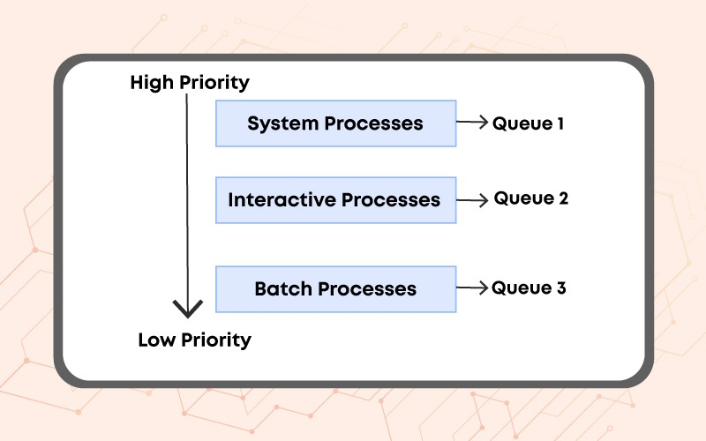
Note: This question was asked in Vmware

(Parameters for MLFQ Scheduler)
10. Which of the following parameters are required to define a multilevel feedback queue scheduler?

Note: This question was asked in Myntra.

a) The number of queues
b) The scheduling algorithm for each queue which can be different from FIFO
c) The method used to determine when to promote a process to a higher priority queue
d) All of these

**********

